**Bansilal Ramnath Agarwal Charitable Trust’s**

**VISHWAKARMA INSTITUTE OF INFORMATION TECHNOLOGY,**

**PUNE-48**

**Department of Information Technology**

**ITUA40201: DATA SCIENCE AND ANALYTICS**

**Assignment-3**

**Shreyas Shripad Kulkarni**

**BTech A Division**

**Roll No.: 431048**

**PRN: 22010443**

**AIM:** Visualization Exercise:

**OBJECTIVE:** Create interactive and meaningful visualizations using specialized data visualization tools.

**TASKS:**

1. Use a data visualization tool (e.g., Tableau, Power BI).
2. Load a dataset related to a specific business scenario (e.g., sales data, customer demographics).
3. Design and develop an interactive dashboard with multiple visualizations, incorporating filters, parameters, and drill-down capabilities.
4. Present insights and provide recommendations based on the visualizations.

**THEORY:**

Microsoft Power BI is a collection of software services, apps, and connectors that work together to turn your unrelated sources of data into coherent, visually immersive, and interactive insights.

Power BI lets you easily connect to your data sources, visualize (or discover) what is important, and share that with anyone or everyone you want.

Power BI can be simple and fast, capable of creating quick insights from an Excel workbook or a local database. But Power BI is also robust and enterprise-grade, ready not only for extensive modelling and real-time analytics.

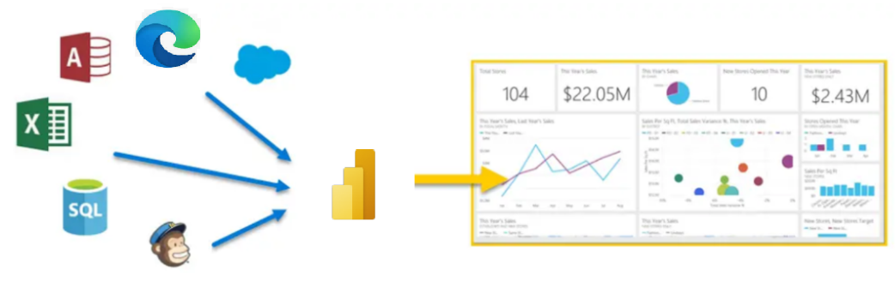

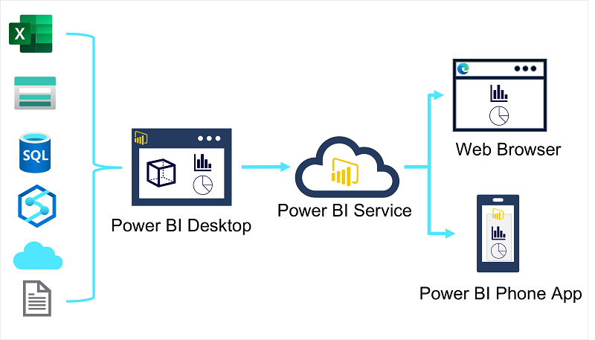

Source: learn.microsoft.com

Once the model the model has been created, we can generate data visualizations that can be included in the report.

* Tables & Text
* Bars & Column Charts
* Line Charts
* Pie Charts
* Scatter Plots
* Maps

**IMPLEMENTATION:**

Step 1: Open Power BI Desktop.

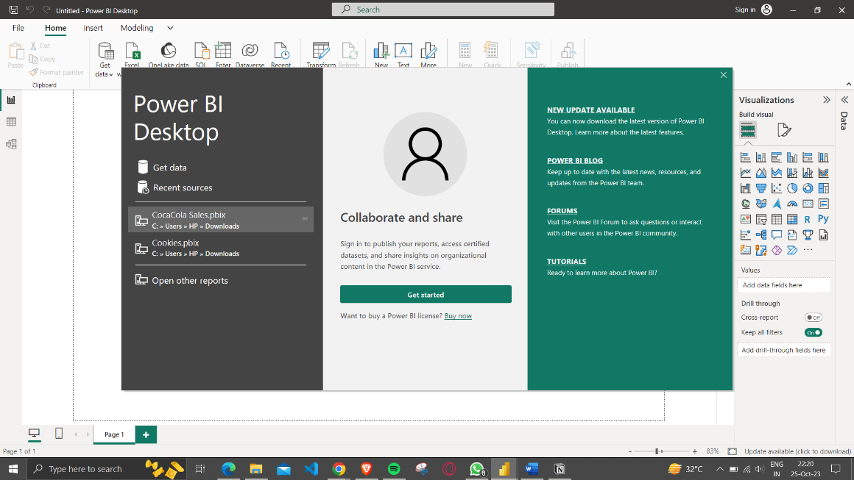

Step 2: Import Data by clicking Get Data

The data to import can be from any common data sources listed.

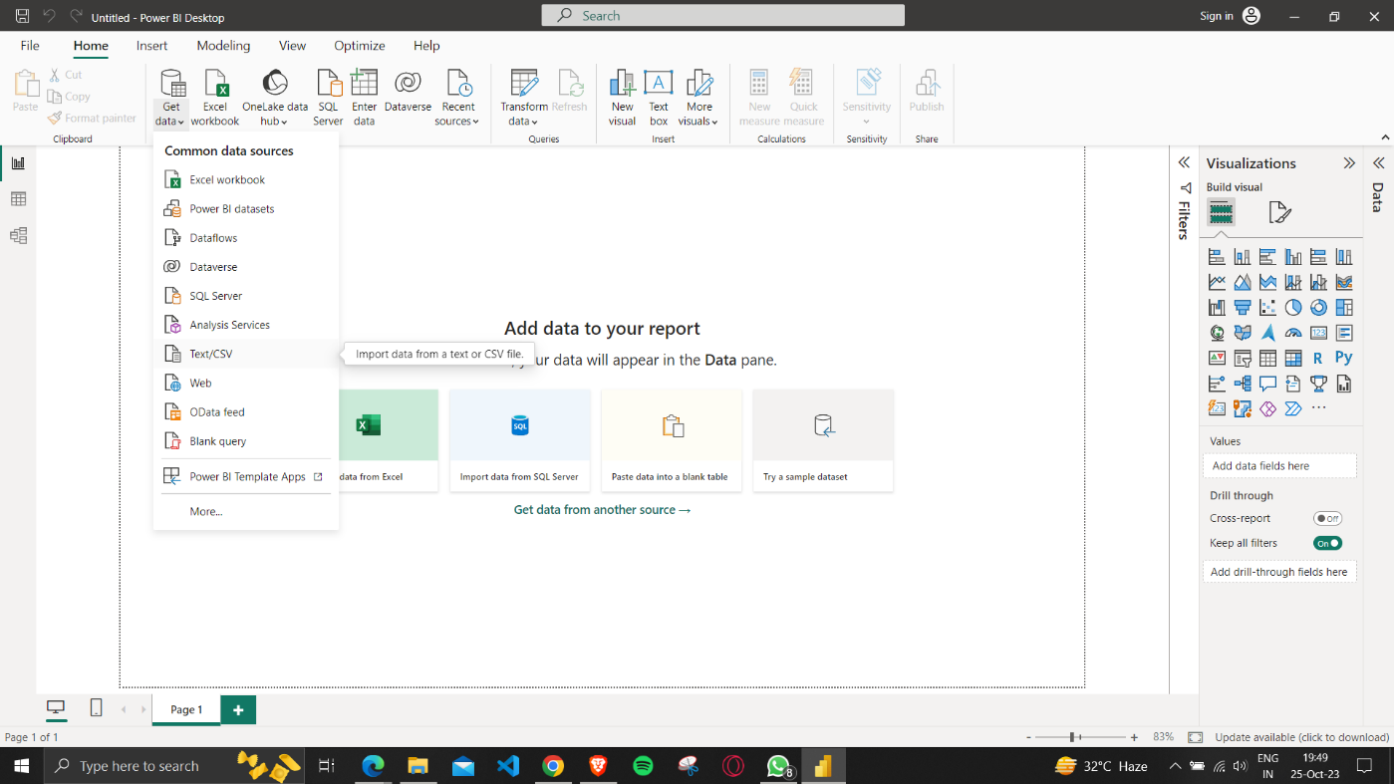

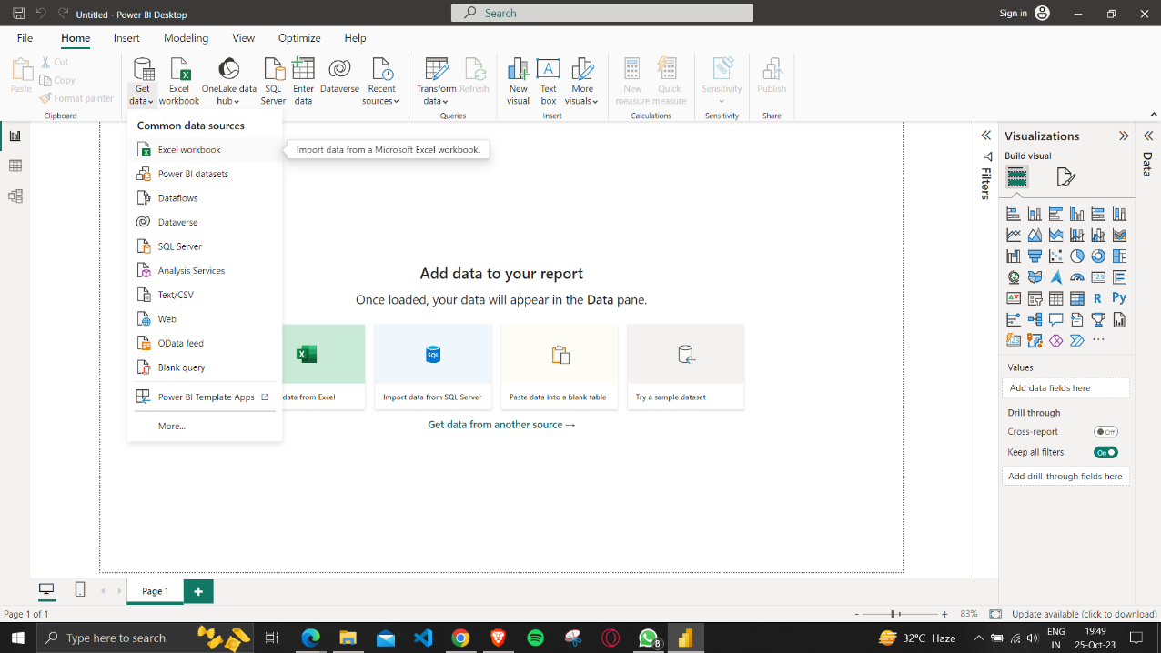

We can also import Dataset from WEB (github/URL)

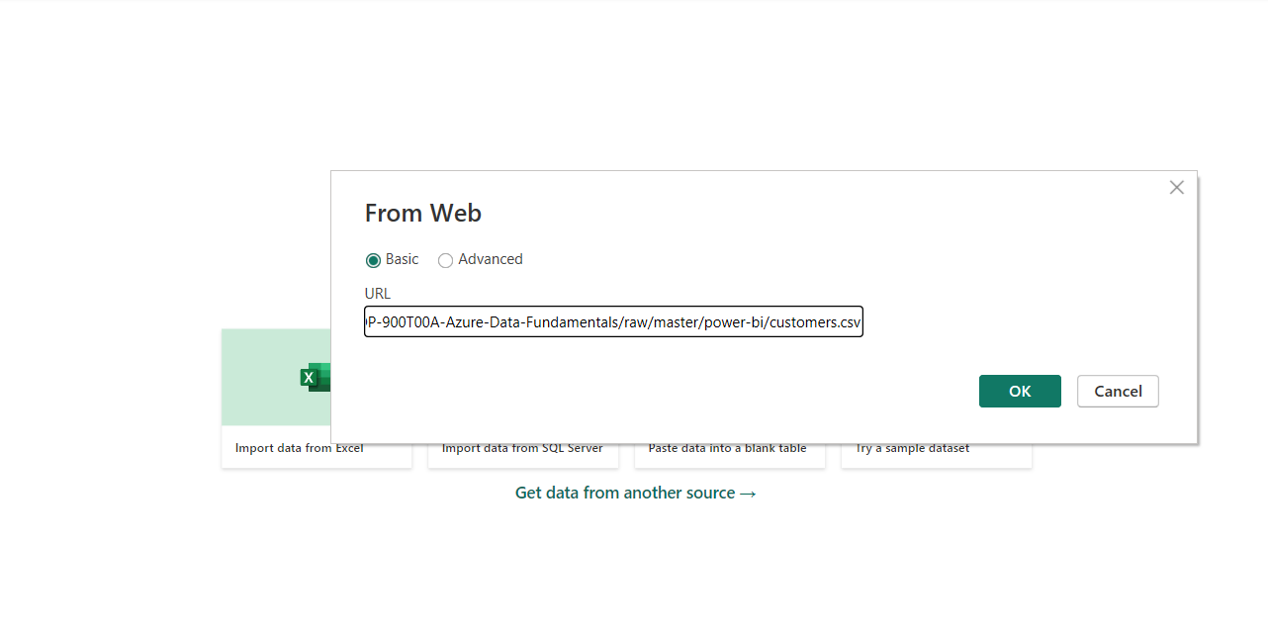

Step 4: We can either Load or transform the data & then Load the dataset

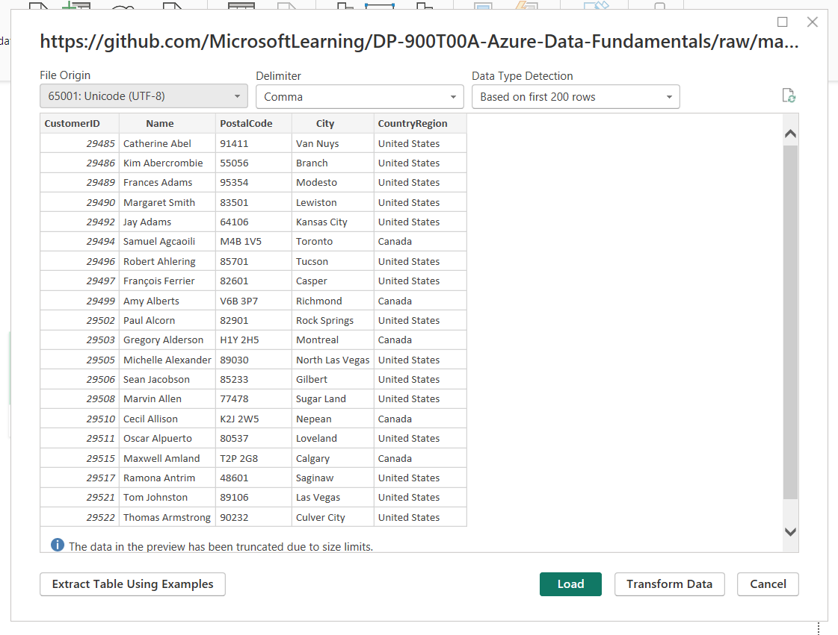

Once the data is loaded we can see the Filters, Visualizations and the Data Tab

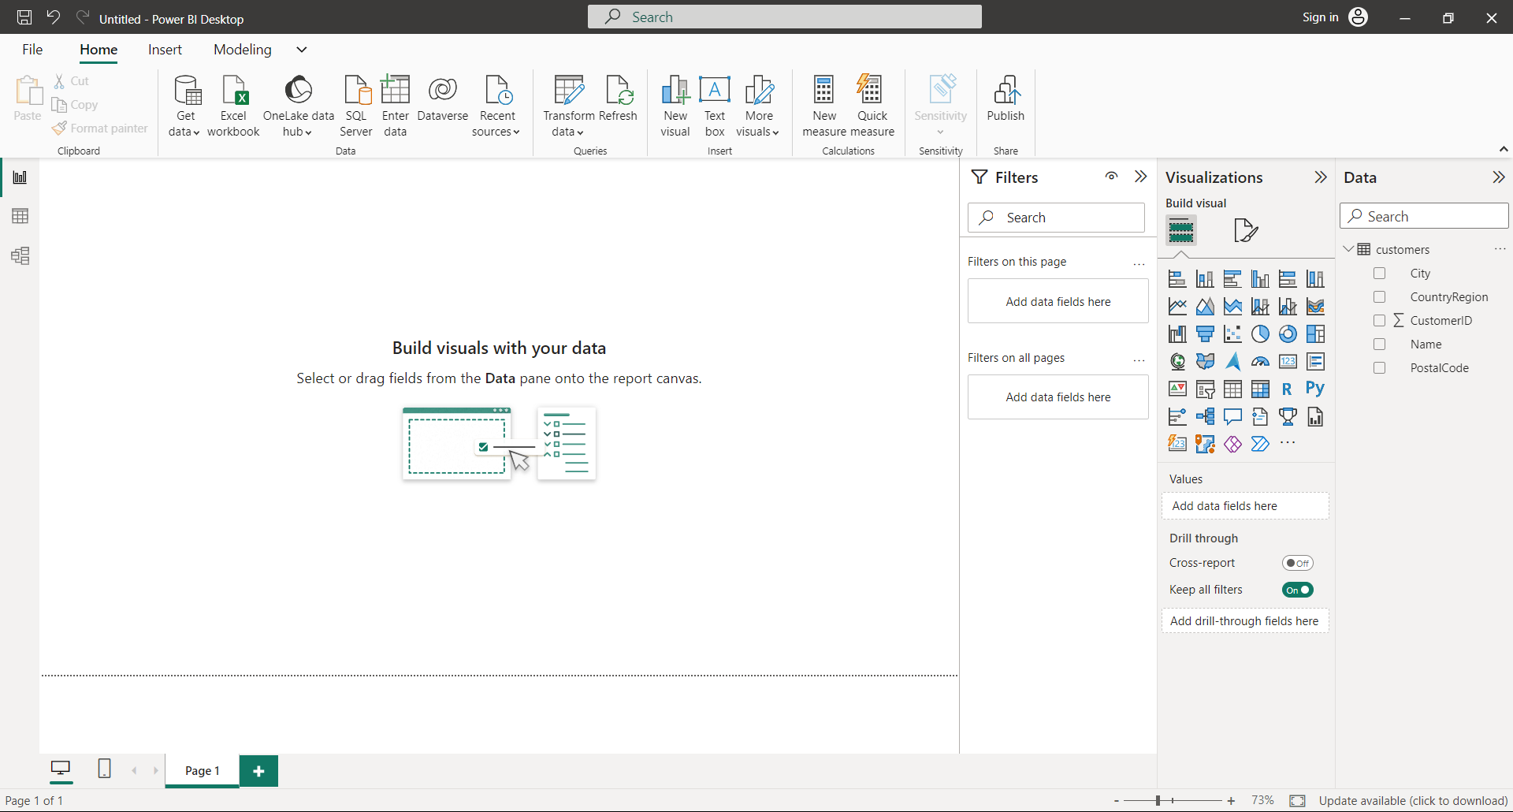

We have three views on the left pane of Power-BI namely:

1. Report View
2. Table View
3. Model View

# EXPLORE MODEL

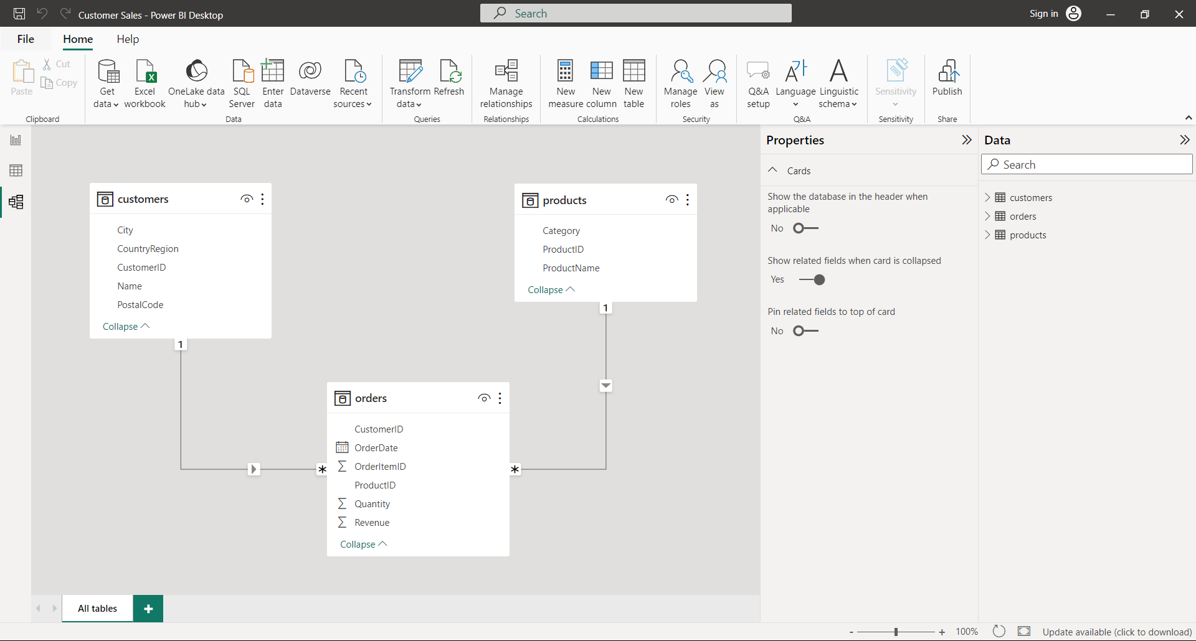

While exploring the model we can Format the type of data

Here we will format our datatype of revenue in Currency.

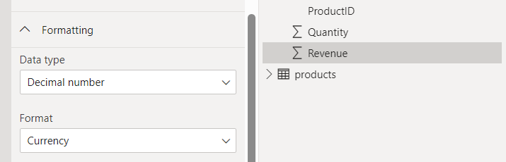

We can also create Hierarchy

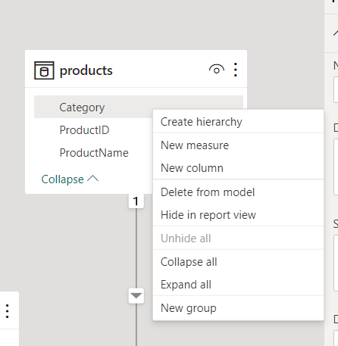

# CREATE REPORT

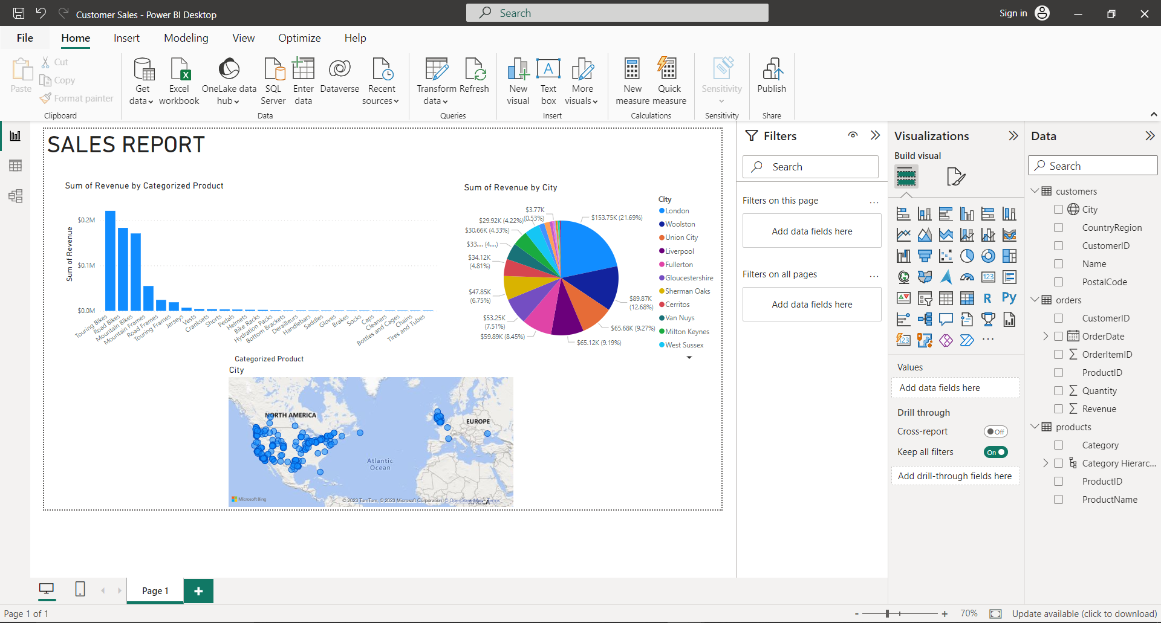

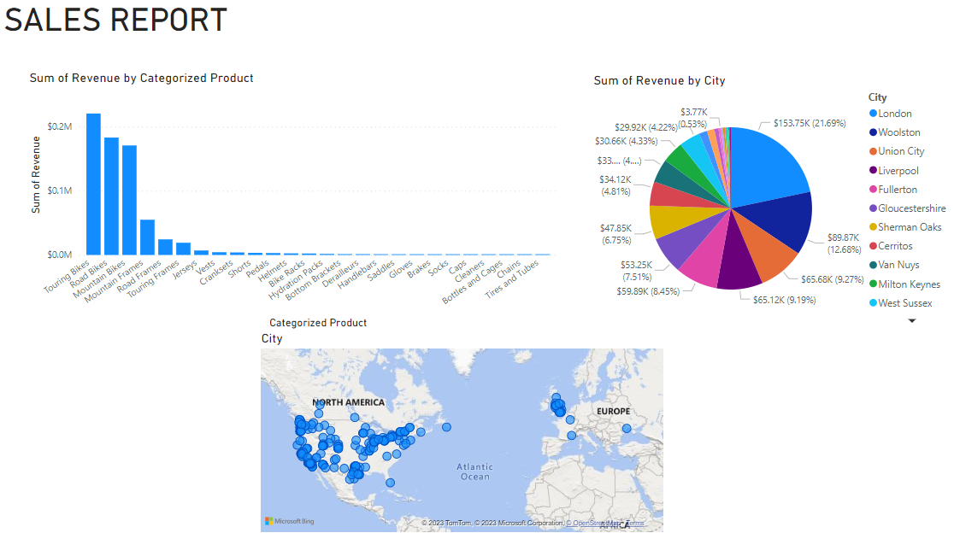

In a Similar Way I have created the sales reports for Coca Cola Sales Dataset & Cookie Sales Dataset.

Coca Cola Dataset

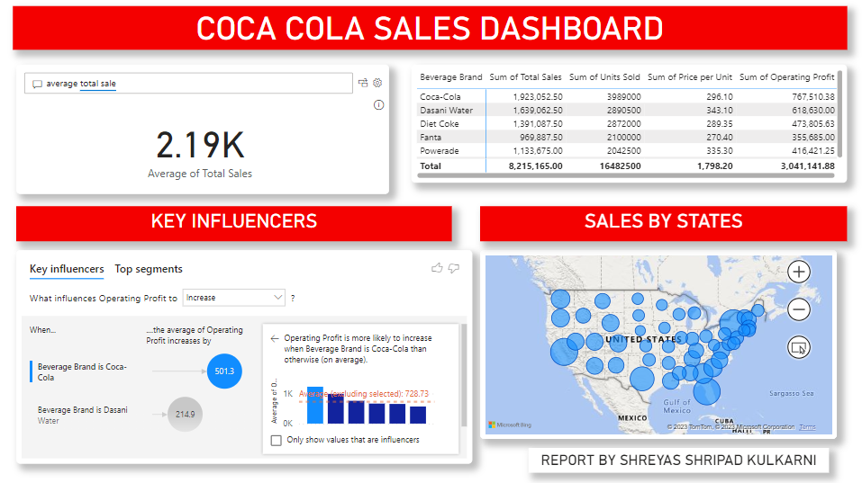

Cookies Sales Dataset

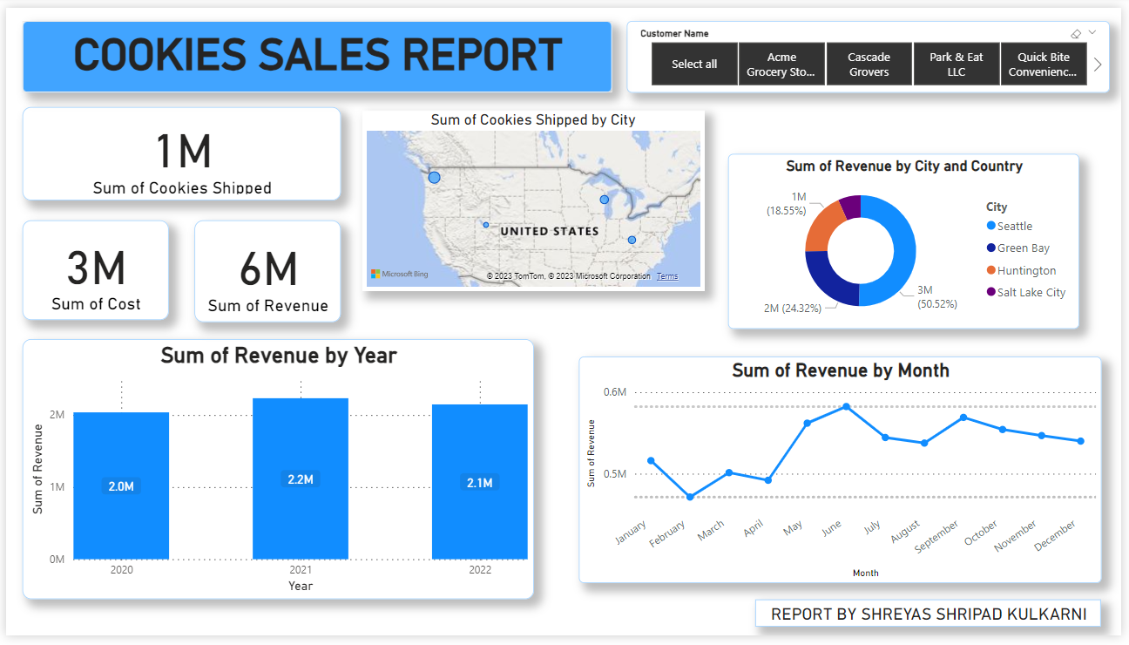

**CONCLUSION**: We have learnt, understood and performed Data Visualization using Power BI.

[GitHub Repository](https://github.com/Shreyas100100/DATA-SCIENCE-AND-ANALYTICS)